**ASSIGNMENT 5 (STARTING WITH CSS)**

1. Create a simple page with some div tags and show different ways to add CSS as well as what happens when you target the same elements with inline, internal, and external CSS. Also, utilize comments in the project where required.

**Index.html**

**<!DOCTYPE html>**

**<html lang="en">**

**<head>**

**<meta charset="UTF-8">**

**<meta name="viewport" content="width=device-width, initial-scale=1.0">**

**<title>Question 1</title>**

**<!-- Internal styles -->**

**<style>**

**.internal {**

**color: green;**

**}**

**.inline__internal {**

**color: red;**

**}**

**.internal__ext {**

**color: brown;**

**}**

**.inline__internal__external {**

**color: aqua;**

**}**

**</style>**

**<link rel="stylesheet" href="style.css">**

**</head>**

**<body>**

**<!-- In this line In-line CSS will render-->**

**<div style="color: rgb(212, 43, 136);">Inline</div>**

**<div class="internal">Internal</div>**

**<div class="external">External</div>**

**<!-- In this line In-line CSS will render-->**

**<div style="color: rgb(50, 5, 90);" class="inline__internal">Inline + Internal</div>**

**<div class="int__external internal__ext">Internal + External</div>**

**<!-- In this line In-line CSS will render-->**

**<div style="color: rgb(41, 19, 61);" class="inline__internal__external">Inline + Internal + External</div>**

**</body>**

**</html>**

**Style.css**

**.external {**

**color: rgb(102, 102, 155);**

**}**

**.int__external {**

**color: rgb(191, 211, 377);**

**}**

**.inline__internal__external {**

**color: rgb(199, 178, 152);**

**}**

**OUTPUT:**

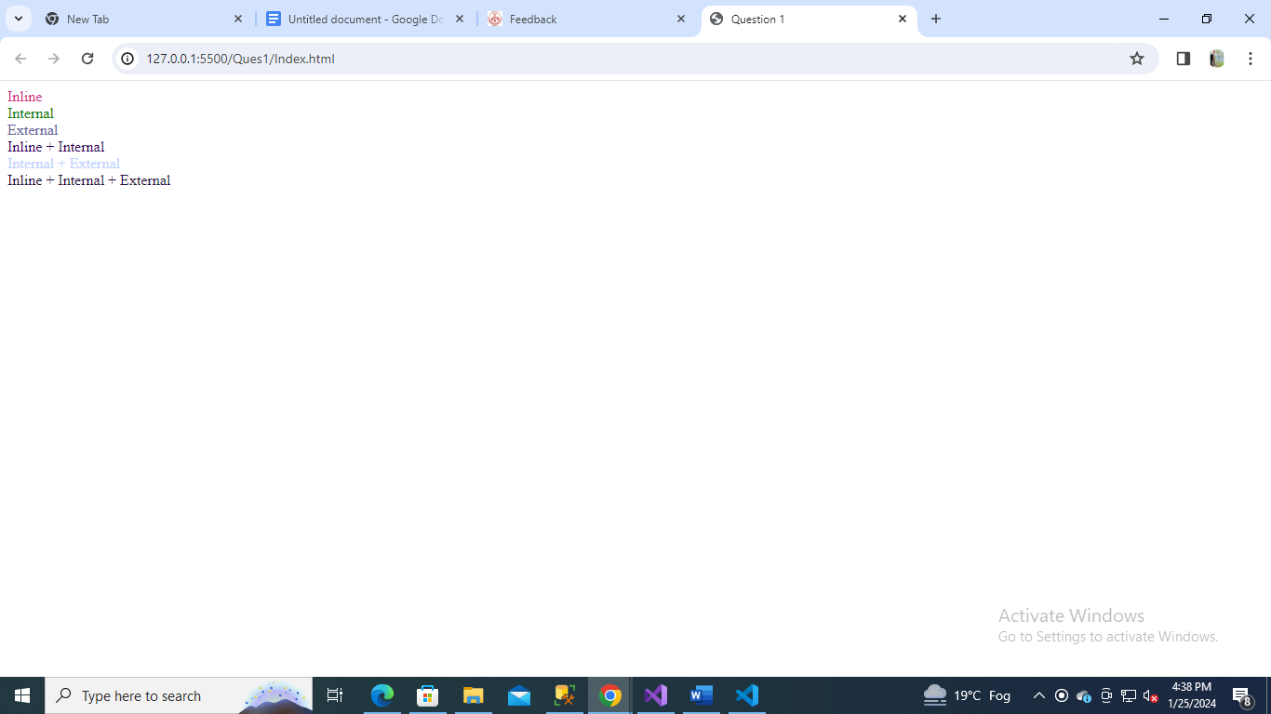

1. Build a HTML page with multiple paragraphs, each assigned a unique class name. Write CSS rules using class selectors to apply distinct styling to each paragraph. Follow the BEM naming convention and explain how you’ve named the classes.

**Index.html**

**<!DOCTYPE html>**

**<html lang="en">**

**<head>**

**<meta charset="UTF-8">**

**<meta name="viewport" content="width=device-width, initial-scale=1.0">**

**<title>Question 2</title>**

**<link rel="stylesheet" href="style.css">**

**</head>**

**<body>**

**<div class="main">**

**<p class="my__heading">This is my heading</p>**

**<p class="my__heading2">This is my heading 2</p>**

**</div>**

**<div class="hero">**

**<p class="my__title">This is my title</p>**

**<p class="my__description">This is my description</p>**

**<button class="btn my__btn-primary">This is my primary button</button>**

**<button class="btn my__btn-secondary">This is my secondary button</button>**

**</div>**

**</body>**

**</html>**

**Style.css**

**.my__heading {**

**color: red;**

**}**

**.my__heading2 {**

**color: blue;**

**}**

**.my__title {**

**color: green;**

**}**

**.my__description {**

**color: brown;**

**}**

**.btn {**

**background-color: #54fa54;**

**}**

**.my__btn-primary {**

**background-color: purple;**

**color: wheat;**

**}**

**.my__btn-secondary {**

**background-color: pink;**

**}**

**OUTPUT:**

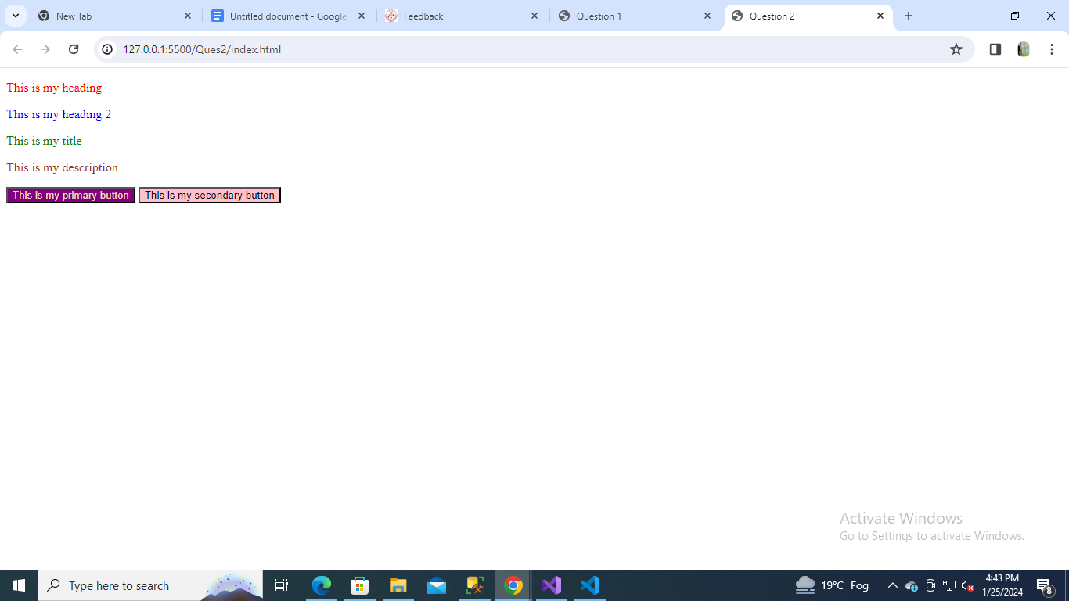

1. Develop an HTML form with various input elements. Use CSS to style the form, including setting background colors for input fields. Create a custom color palette for the form elements, and demonstrate how to apply opacity to one of the form sections.

**Index.html**

**<!DOCTYPE html>**

**<html lang="en">**

**<head>**

**<meta charset="UTF-8">**

**<meta name="viewport" content="width=device-width, initial-scale=1.0">**

**<title>Question 3</title>**

**<link rel="stylesheet" href="style.css">**

**</head>**

**<body>**

**<div id="form">**

**<h1>Form with various input elements</h1>**

**<form>**

**<div class="row">**

**<div class="column">**

**<label for="firstName">First Name:</label>**

**</div>**

**<div class="column">**

**<input type="text" name="firstName" class="firstName" placeholder="John" id="firstName" required minlength=3 max=20 />**

**</div>**

**</div>**

**<div class="row">**

**<div class="column">**

**<label for="lastName">Last Name:</label>**

**</div>**

**<div class="column">**

**<input type="text" name="lastName" class="lastName" placeholder="Doe" id="lastName" required min=3 max=20 />**

**</div>**

**</div>**

**<div class="row">**

**<div class="column">**

**<label for="email">Email:</label>**

**</div>**

**<div class="column">**

**<input type="email" name="email" class="email" placeholder="john@doe.com" id="email" required />**

**</div>**

**</div>**

**<div class="row">**

**<div class="column">**

**<label for="age">Age:</label>**

**</div>**

**<div class="column">**

**<input type="number" name="age" class="age" placeholder="38" id="age" required min=0 max=150 />**

**</div>**

**</div>**

**<div class="row">**

**<div class="column">**

**<label for="">Gender:</label>**

**</div>**

**<div class="column">**

**<input type="radio" id="male" value="male" name="gender" checked />**

**<label for="male">Male</label><br>**

**<input type="radio" id="female" value="female" name="gender" />**

**<label for="female">Female</label><br>**

**<input type="radio" id="other" value="other" name="gender" />**

**<label for="other">Other</label>**

**</div>**

**</div>**

**<div class="row">**

**<div class="column">**

**<label for="password">Password:</label>**

**</div>**

**<div class="column">**

**<input type="password" name="password" class="password" placeholder="********" id="password" required min=8 />**

**</div>**

**</div>**

**<div class="row">**

**<div class="column">**

**<label for="confirmPassword">Confirm Password:</label>**

**</div>**

**<div class="column">**

**<input type="password" name="confirmPassword" class="confirmPassword" placeholder="********" id="confirmPassword" required />**

**</div>**

**</div>**

**<div class="row" style="width: 100%;">**

**<div class="column">**

**<input type="checkbox" id="terms" required class="checkbox" /> I agree to terms and conditions**

**</div>**

**</div>**

**<div class="row">**

**<button type="submit">Register</button>**

**</div>**

**</form>**

**</div>**

**</body>**

**</html>**

**Style.css**

**#form {**

**background-color: lightsalmon;**

**border: 2px solid black;**

**padding: 40px;**

**position: absolute;**

**margin-left: auto;**

**margin-right: auto;**

**margin-top: auto;**

**}**

**.row{**

**display: flex;**

**width: 50%;**

**margin: 10px;**

**}**

**.column{**

**width: 50%;**

**}**

**.form-column {**

**padding-top: calc(0.375rem + var(--bs-border-width));**

**padding-bottom: calc(0.375rem + var(--bs-border-width));**

**margin-bottom: 0;**

**font-size: inherit;**

**line-height: 1.5;**

**}**

**.firstName {**

**background-color: red;**

**}**

**.lastName {**

**background-color: green;**

**}**

**.email {**

**background-color: yellow;**

**}**

**#terms:checked {**

**accent-color: violet;**

**}**

**button {**

**opacity: 50%;**

**}**

**OUTPUT**

